Assignment no 3

* Created .war file on one machine





* Jenkins running

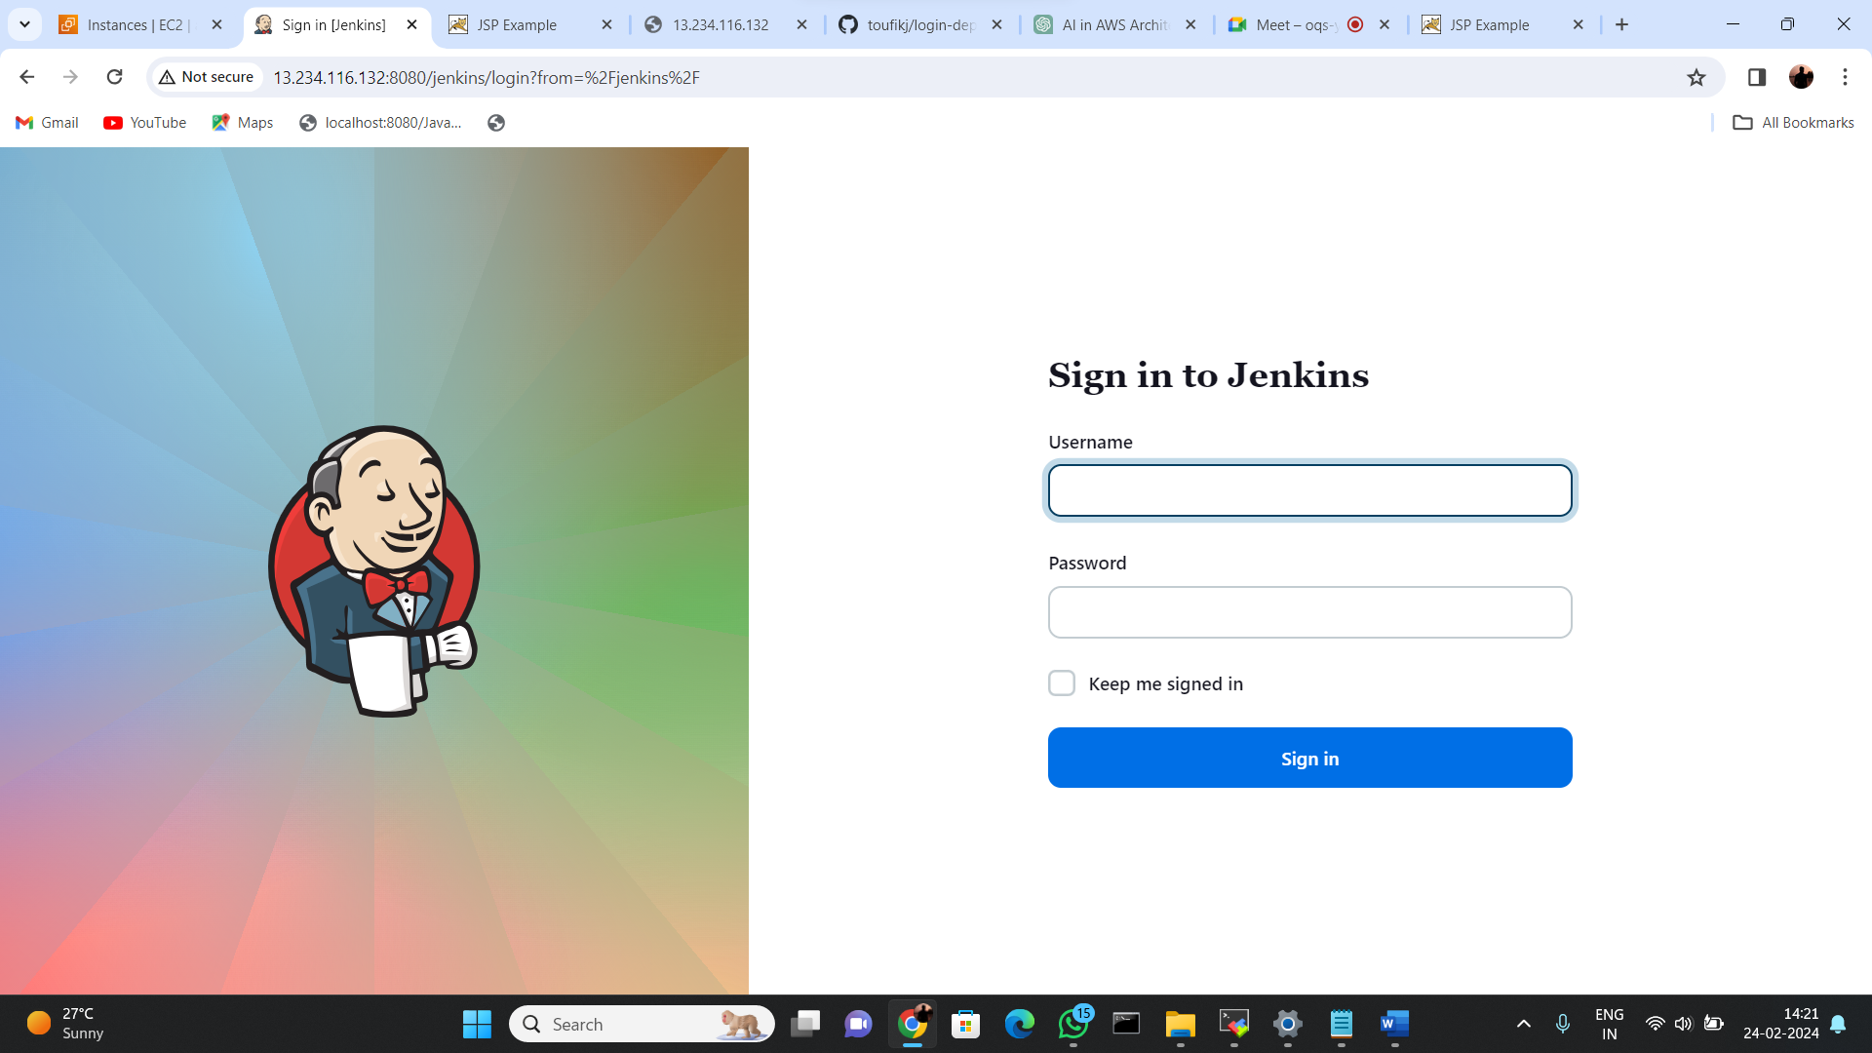

* Pushing .war file to remote repo

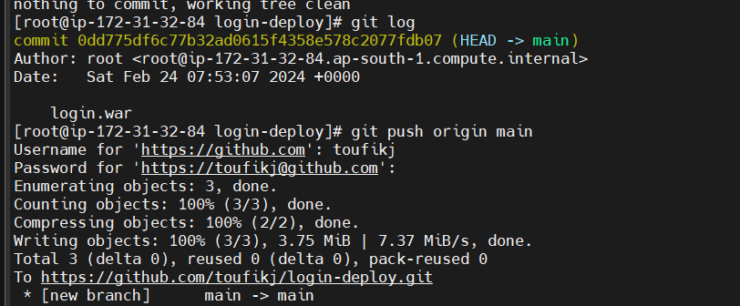

* Cloning repo in 2nd instance

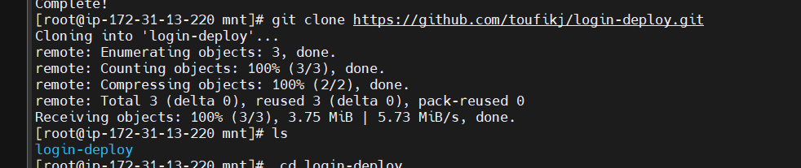

* Coping .war file to tomcat server

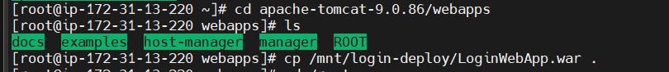

* Running of loginwebapps on tomcat

